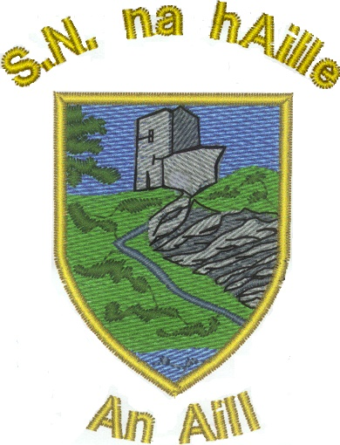 | NAUL NATIONAL SCHOOL  APPLICATION FOR ADMISSION 2024/2025  Note: Any information you give on this form will be treated with the strictest confidence and will be used only for the benefit of your child.
USE BLOCK CAPITALS PLEASE
Childs Name: |  |  | Surname in Irish if known:
Date of Birth: / / |  |  | Sex: MALE FEMALE
PPS Number:
No. Of Children in Family: |  |  | Place in Family: (1st, 2nd etc)
Name and Class of Siblings already in school:
Address:
Nationality: |  |  | Date of Arrival in Ireland:
Language spoken at home: |  |  | Religion: (optional)  Ethnicity: (optional)
Mother’s Name:  Mother’s Maiden name: |  | Occupation:
Mother’s Address:
Mother’s Phone: Mobile: Work: Home:
Mother’s Email:
Father’s Name: |  | Occupation:
Father’s Address:
Father’s Phone: Mobile: Work: Home:
Father’s Email:
Home Address where Pupil Normally resides:
Date of Entrance to this school: |  | Was your child at school before:
Name of previous school: |  | Class:
I/we consent for this information: pps number of child, date of birth of child, mothers name and maiden name, fathers’ name, language spoken at home, no. of children in the family, to be stored on the Primary Online Database (POD) and transferred to the department of education and skills and to other primary schools my child may transfer to during the course of their time in primary school. Ethnicity and Religion entries are optional.
I understand that this will only be commenced if my child is accepted into the school.
Yes ____ NO____
Other details.
 |  |  |  |  | YES | NO
Has your child ever had any type of education assessment? e.g referral to an early intervention team?
Or
Referral to speech therapy services?
If YES please give details:
Has your child any allergies?
If YES please give details:
Does your child appear to have any difficulty with the following?
Hearing
Speech
Vision
If YES please give details:

Name of Childs/family Doctor:
Address: |  |  |  | Phone:
Contact Persons if Parents not available:
1st Contact: | Phone:
2nd Contact | Phone
 |  | Yes | NO
Do you give permission for your child to go on school trips, under teacher supervision, during the school day, e.g. to the village, church, Christmas pantomime, school tours etc..?
Do you give permission for your child to be transported to and from sports matches?
Sometimes journalists visit the school to photograph sports events/activities, Christmas shows, award/prize giving etc. Do you give permission for your child to be photographed?
Note: The Board of Management cannot be held responsible for pictures/videos taken by parents at school events
Please visit the school’s website naulschool.ie. Do you give permission for your child’s photograph/videos of your child (without their name) to be used on the website and on Naul N.S. social media pages, e.g. Instagram, Facebook etc.
Sometimes the school is requested to pass on pupils’ names and addresses to the Health Board for immunization purposes, to secondary schools for use when pupils are transitioning to second level, to sports bodies when pupils are taking part in games outside school. Do you give permission for your child’s details to be made available to these bodies?
Has your child received all up to date immunizations for their age ____Yes____No
If no give details __________________________________________________________________________________________________________________________________________
Any other information you feel we should be made aware of

Signed: _______________________, ___________________________

Please fill in and return to the School Officeby Post or by Email to naulns1834@gmail.com

